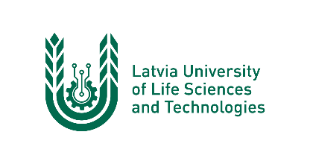

ERASMUS+ programme
KA1: Learning Mobility of Individuals
Staﬀ Mobility for Teaching
Letter of Conﬁrmation
Academic year
GADS/GADS

This is to certify, that
vārds, uzvārds
Mr./Ms.

from LATVIA UNIVERSITY OF LIFE SCIENCES AND TECHNOLOGIES (LV JELGAVA01)

has delivered 8 hours lectures under ERASMUS+ programme: KA1 Staﬀ Mobility for Teaching at

viesaugstskolas nosaukums

name of institution/enterprise
between the following dates

 | and
day/month/year |  | day/month/year

Date: Signature and stamp:
Name of responsible person:
Position of responsible person at the host institution:

